USA College Day 2026: Publicity Toolkit

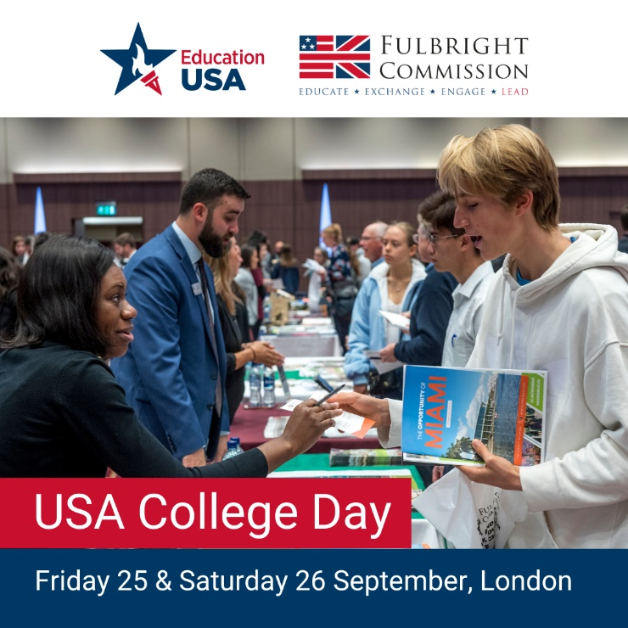 | Follow and tag  US-UK Fulbright Commission  Instagram - @usukfulbright  LinkedIn - us-uk-fulbright-commission  You can download the graphic to the left here.
How you can spread the word about USA College Day
Suggested Social Media Copy:
Ready to explore university options? You’re in luck: the US college fair experience is coming to you! Register for USA College Day in London on 25-26 September, where you can connect with representatives from 120+ US universities and explore your future path. Secure your free spot: https://fulbright.org.uk/educationusa-advice/college-day-2026/
Are you interested in pursuing an undergraduate degree in the US? On 25 or 26 September, connect in-person with representatives from 120+ US universities at USA College Day. Explore programmes, ask questions, and set your sights on global education. Get your free ticket today: https://fulbright.org.uk/educationusa-advice/college-day-2026/
Ready to explore your college pathway to the US? Register for USA College Day on 25 or 26 September to engage with over 120 university representatives from across the US. Discover courses available, campus life, and more as you prepare for your undergraduate degree. Sign up here for a free ticket: https://fulbright.org.uk/educationusa-advice/college-day-2026/
Suggested Newsletter Paragraph:
USA College Day, the biggest US university fair in Europe, is just around the corner on September 25-26. The event provides students, parents and teachers with the unique opportunity to meet representatives from over 120 American universities. You'll have the chance to learn about different institutions, discover financial aid and scholarships, and find out more about the admissions process. Register for free here: https://fulbright.org.uk/educationusa-advice/college-day-2026/

